CC6 Race notes:
Date: Sunday 13th February
Start: 9:30am prompt
Race distance: 4.3m (6.9km) approximately. Hilly, gravel tracks.
Car Parking (SO43 7HH):
The car park gate will be open from 8:00am and will close at 12:00pm
Ocknell Campsite is the ONLY allowed car park for this event in line with Forestry England guidelines. All other car parks are out of bounds along with any verge parking. Any deviation from this will severely jeopardise any future events.
To access the start area, follow the path out of the car park and along the roadside. Take care walking along the road. Please follow the marshal’s instructions. Walking is not allowed across open heathland. Please allow 10-15mins to get to the start area.
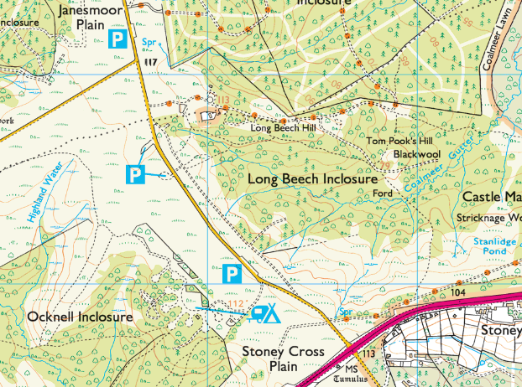
Race Car Park
Ocknell Campsite ONLY

Setup area:
Longbeech Campsite
The race set up point is along the path in Longbeech Campsite. No tent pegs are to be used in the grassy areas.
Refreshments:
There will be water available at the event finish area. Please bring your own cup or drinking bottle as cups will not be provided.
There will a selection of cakes available in CC6 tradition. A special thanks to the members of Totton Running Club for all their contributions.
Facilities:
Note; there will NOT be any toilet facilities available at the Start/Finish area or at the Car Park.
Please also note the car park will be closed at 12pm prompt. If you wish to run or walk after the event you will have to move your vehicle to another location after the event
COVID
Face coverings are no longer required but wear one if you are at all concerned. The start will be in a wide-open area so plenty of room to spread out. If you have tested Positive, please do not attend.
Refer to the latest Govt advice:
https://www.gov.uk/coronavirus

PLEASE ALSO NOTE: AS THIS EVENT FALLS WITHIN THE GROUND NESTING BIRD SEASON IT MAY BE SUBJECT TO CANCELLATION AT SHORT NOTICE BY FORESTRY ENGLAND.

On behalf of: Totton Running Club

