CC6 Race 5 – Roundhill Campsite
Sunday 30th Jan, start at 0930
Romsey Road Runners, Halterworth Harriers and Southampton Tri Club are hosting the next CC6 race at Roundhill campsite Brockenhurst.
Parking and race HQ will be at the campsite, Beaulieu Rd, Brockenhurst SO42 7QL. Parking will be strictly at the campsite, please car share if possible. The car park will be open from 0830.
We hope to provide hot drinks at the finish, but please bring your own water.
The course is about 4.5 miles, mainly on made up tracks. A small part of the course may be muddy. Road shoes should be fine. Route is shown below, and will be well marshaled on the day. Please note that the course start is about 10 minutes walk from the car park and race HQ so please arrive in good time.

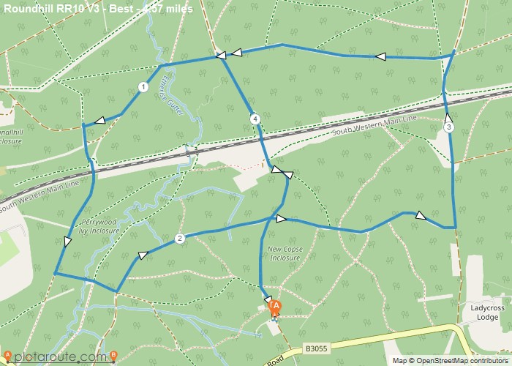
As with other races this season, please don’t attend if you’re feeling unwell or have been in recent contact with anyone who is Covid positive.
I look forward to seeing you all there

