RACE CAR PARK

We have been allocated Ocknell Campsite Car Park.(SO43 7HH) This is a large car park and will easily cope with our expected numbers. All runners must use this car park. There will be no exceptions. If you try and use other local car parks you will be moved on up the road to Ocknell. Also there will be strictly no parking on verges. These conditions have been agreed with Forestry England and Natural England in order for us to hold this event. If you ignore these instructions it will severely affect our chances of holding future events in the forest.

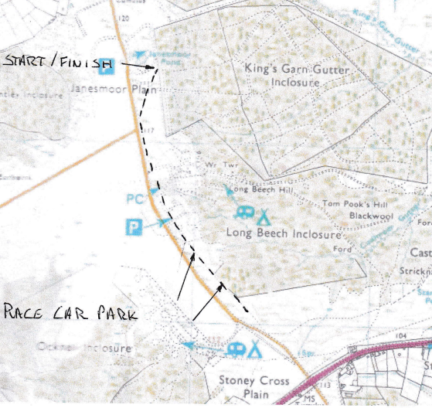

The car park gate will be unlocked at 08. 00 and locked again at 12. 00.

The car park is 1 mile approx. from the start/finish, along the footpath that runs along the side of the road (see map). Please use this footpath and for your own safety please don't walk directly alongside the road.

