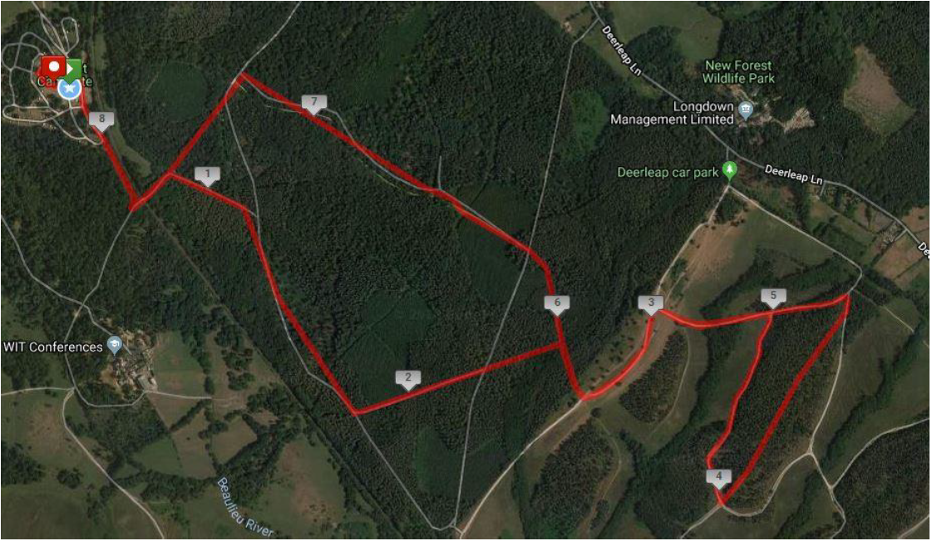

M

M

Mx2

M

M

Mx2

M

M

M

M

Mx2

Mx2

M

M

M

Mx2

M

M

M

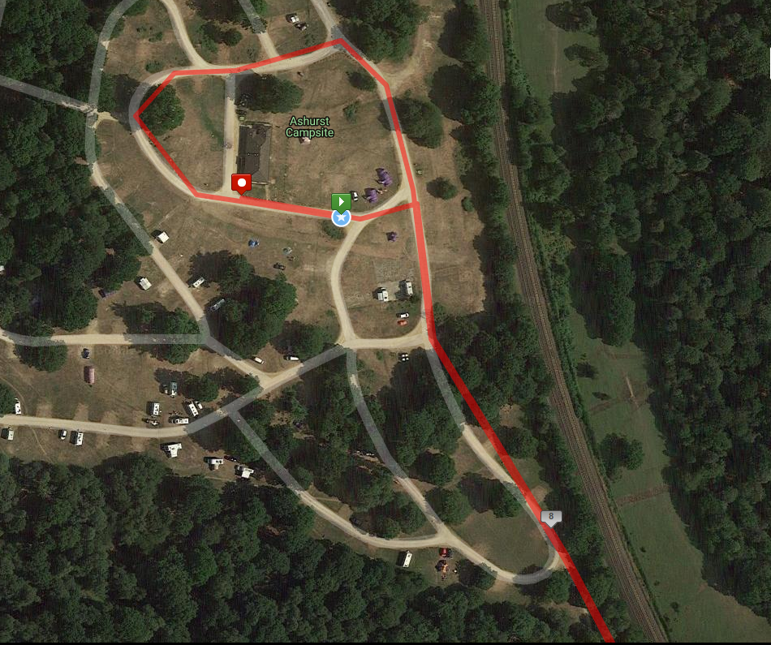

FINISH

START

M

M

M

M

M