21st January 2018 - Kings Garn Gutter Inclosure, Stoney Cross
Romsey Road Runners, Halterworth Harriers & Southampton Tri Club
Directions:
- Leave M27 at Junction 1 (there is no right turn for Stoney Cross from the A31)
- Drive through Brook
- Turn left onto B3078 after the pubs
- Turn left after 1.5 miles
- Pass Janesmoor Pond and Longbeech campsite on the left
- Parking is in two areas – Stoney Cross Plain and Stoney Cross.- (NB - providing that the entrance gates to Janesmoor carpark are not locked on the day, Marshals are requested to park at Janesmoor Pond car park and then walk to the race area).
- Walk to the race area via Longbeech campsite.
- Please make every effort to car share where possible.
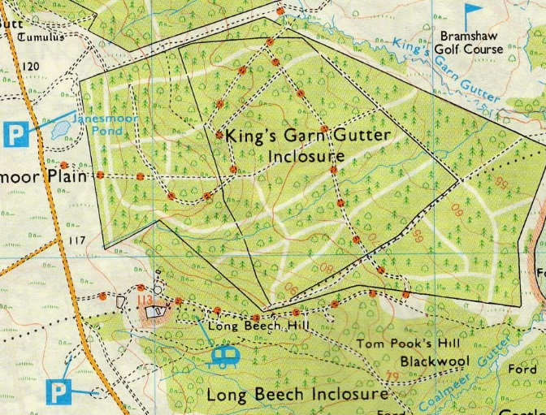
Entrance to race area
Start
Finish
Race parking

Course:
This is a challenging course of about 4.5 miles, with two laps of the middle section and a climb to the finish, run on a mixture of gravel and very muddy forest tracks – don’t expect to finish with dry socks!
There are no changing or toilet facilities.

